
URBAN PULSE Smart City Mobility Intelligence Platform
A Power BI–Based Business Intelligence Project Report

Submitted by:
R.Jaswanth Kumar
Ritu sungar
Unnatii
Madhuri
Under the guidance of:
Dr.sathya

Table of contents:

- Objective
- Project Description
- Eight-Phase Project Overview
- Project Milestones
- Datasets
- Project Execution / Workflow
- Dashboard Development
- Key Analytical Outputs
- Challenges
- Pros and Cons
- Learnings
- Skills Gained
- Team Testimonials
- Conclusion
- Acknowledgements

OBJECTIVE:

The objective of the Infosys Urban Pulse project is to design and develop an interactive Power BI–based Smart City Mobility Intelligence Platform that brings together transportation, weather, and ride-hailing data on a single analytical platform.
The platform is intended to analyze urban mobility patterns, travel demand, revenue performance, operational efficiency,accessibility, seasonal trends, and mobility equality across different locations. By combining these data sources, the project aims to convert raw, disconnected urban data into meaningful, decision-ready insights that support smarter and more informed urban planning.
PROJECT DESCRIPTION:

This project focuses on building an end-to-end data analytics and business intelligence solution for smart-city mobility. It follows the complete analytics lifecycle — starting from data collection and preprocessing, moving through data integration and ETL (Extract, Transform, Load), and continuing into data modeling, DAX-based calculations, visualization, dashboard development, and final insight generation.
The platform analyzes transportation, weather, and ride-hailing information together to understand mobility demand, travel patterns, the influence of weather on travel behavior, operational performance, customer and vehicle behavior, revenue trends, seasonal variation, mode substitution, and mobility equality across different areas of the city.
The solution is implemented entirely in Microsoft Power BI and makes use of Power Query for data transformation, Star Schema and Snowflake Schema data modeling, DAX measures and calculated columns, KPI cards, and a range of visuals including maps, heat maps, Sankey diagrams, and other analytical charts.
EIGHT-PHASE PROJECT OVERVIEW:

Phase | Focus Area | Key Activities
Phase 1 | Data Visualization & Data Fundamentals | Introduction to data visualization principles, the data-to-decision flow, and the types of data used in the project.
Phase 2 | Smart City Data & Data Integration | Exploration of smart-city datasets, the data integration process, data sources, and the challenges involved along with their solutions.
Phase 3 | ETL Process | Extraction, transformation, and loading of raw data, along with data cleaning and preparation for analysis.
Phase 4 | Data Visualization in Power BI | Use of bar, column, line, pie/donut, area, ribbon, waterfall, and scatter charts, along with maps, heat maps, Sankey diagrams, and treemaps.
Phase 5 | Power BI Data Types & Date/Time | Working with Power BI data types and date-time manipulation, including year, month, day, week, quarter, time slots, and peak-hour analysis.
Phase 6 | Power Query & M Language | Use of Power Query and the M language for data preprocessing, along with grouping and aggregate functions.
Phase 7 | Data Modeling in Power BI | Building Star Schema and Snowflake Schema data models, defining relationships, and creating date, dimension, and fact tables.
Phase 8 | DAX & Analytical Calculations | Development of DAX measures and calculated columns, understanding the difference between measures and columns, and building KPIs and analytical calculations.

PROJECTMILESTONES:
The project execution was organized around four major milestones, each representing a significant stage of progress and deliverable.

Milestone 1 — Initial Data Visualization
Visualization of the transportation, weather, and ride-hailing datasets to understand their structure, patterns, and initial trends.

Milestone 2 — Data Processing, Modeling & Dashboard Development
Data processing and cleaning, followed by the implementation of Star Schema and Snowflake Schema data models, and the development of the first set of interactive dashboards.

Milestone 3 — Weather Analytics
Development of a dedicated Weather Analytics dashboard to study weather conditions and their impact on urban mobility.

Milestone 4 — Advanced Mobility Analytics
Development of the Ride-Hailing Mobility dashboard, the Seasonal dashboard, mode substitution analysis dashboard , and the Mobility Equality dashboard.
DATASETS :
Three core datasets were used to build the analytical platform, each contributing a different dimension of urban mobility insight.

PROJECT WORKFLOW :
The project was executed as an end-to-end workflow, with each stage feeding into the next to progressively build the final mobility intelligence platform.
Data Collection → Data Understanding → Data Cleaning → Data Integration → ETL → Feature Engineering → Data Modeling → Star Schema → Snowflake Schema → DAX Measures → KPI Development → Data Visualization → Interactive Dashboard Development → Analytical Insights → Final Mobility Intelligence Platform

MAJOR POWER BI ACTIVITIES:
- Data import from transportation, weather, and ride-hailing sources
- Power Query preprocessing and data transformation
- Missing-value handling and duplicate removal
- Data-type conversion and date/time transformation
- Feature engineering for analytical readiness
- Defining relationships between fact and dimension tables
- Building Star Schema and Snowflake Schema models
- Creating DAX measures and calculated columns
- Designing KPI cards, slicers, and filters
- Building interactive charts, maps, and geographical visuals
- Generating dashboard-based analytical insights

DASHBOARD DEVELOPMENT :
Dashboard development formed the core deliverable of the project. Each dashboard was designed to answer specific analytical questions using a combination of KPI cards, charts, maps, and interactive filters, allowing users to explore mobility patterns from different perspectives.
MOBILITY OVERVIEW DASHBOARD:Provides a consolidated view of transportation and ride-hailing activity, including demand trends, peak time slots, 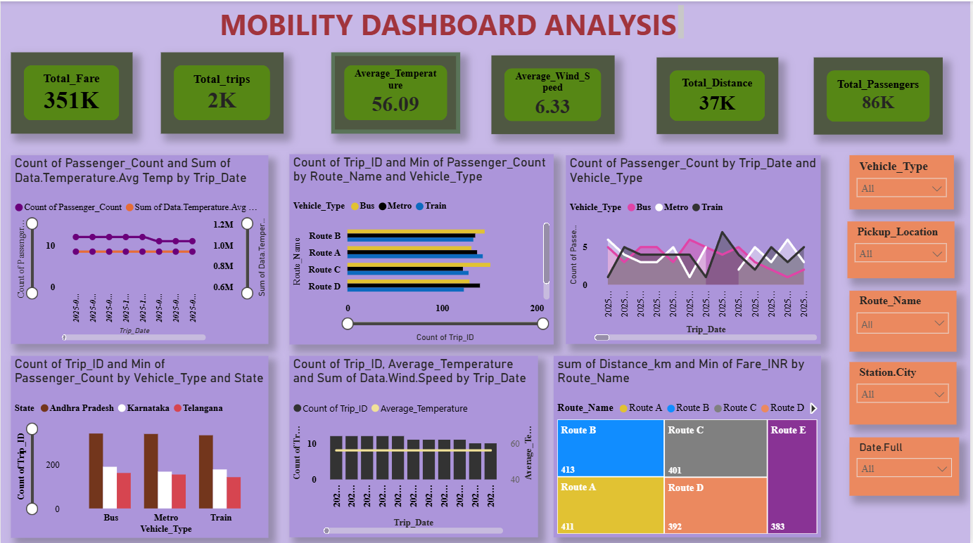

RIDE-HAILING MOBILITY DASHBOARD:
Focuses on ride demand, revenue, customer behavior, and vehicle-level operational performance, using interactive charts and KPI indicators.

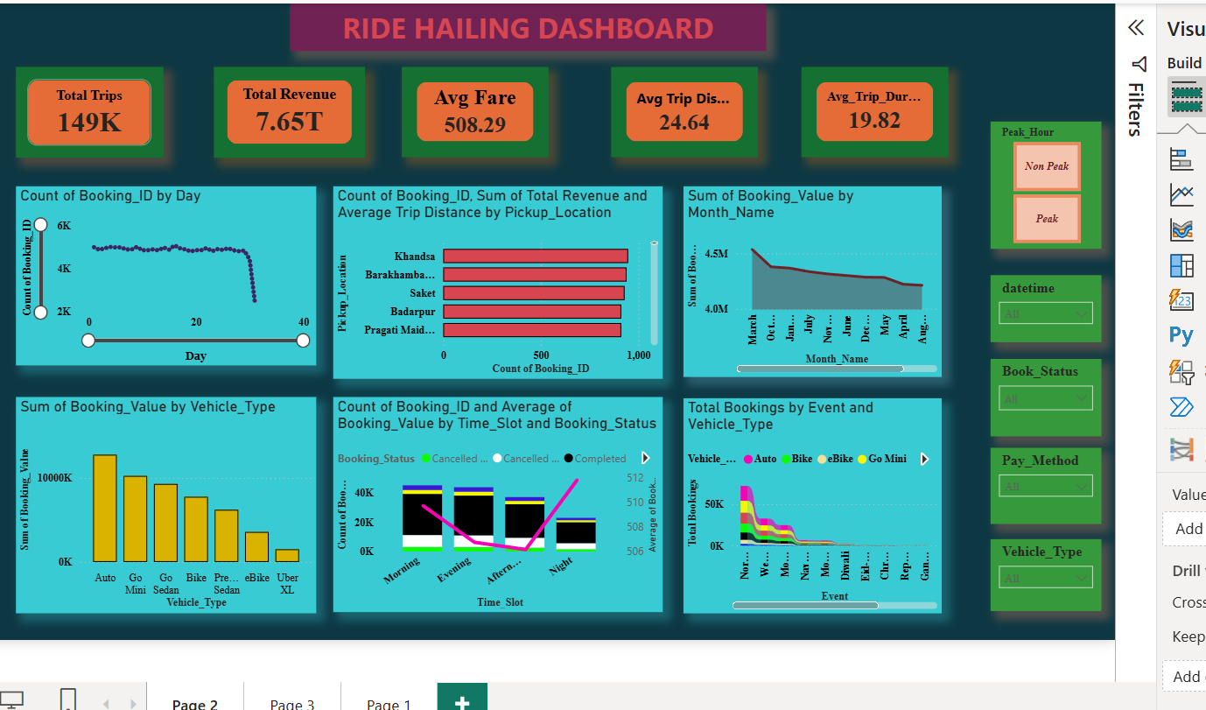

MOBILITY EQUALITY DASHBOARD:
Examines seasonal variation in mobility demand, mode substitution behavior, and mobility equality across different locations, using maps, heat maps, and Sankey diagrams
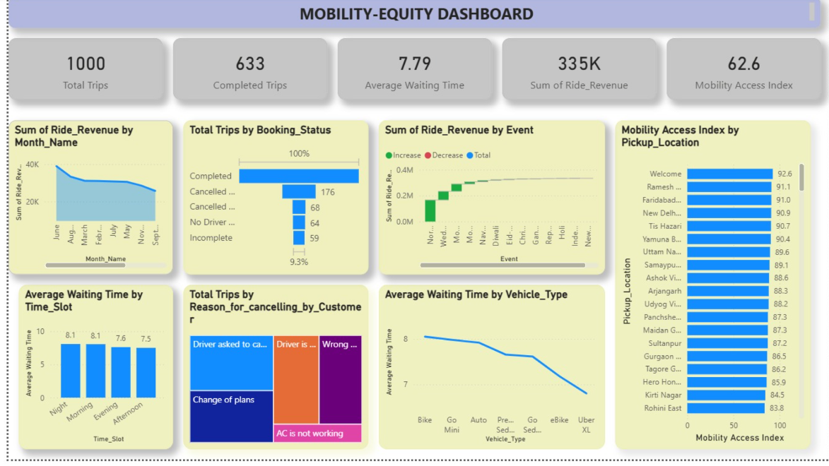
FORECAST AND ANAMOLY INTELEGENCE DASHBOARD:
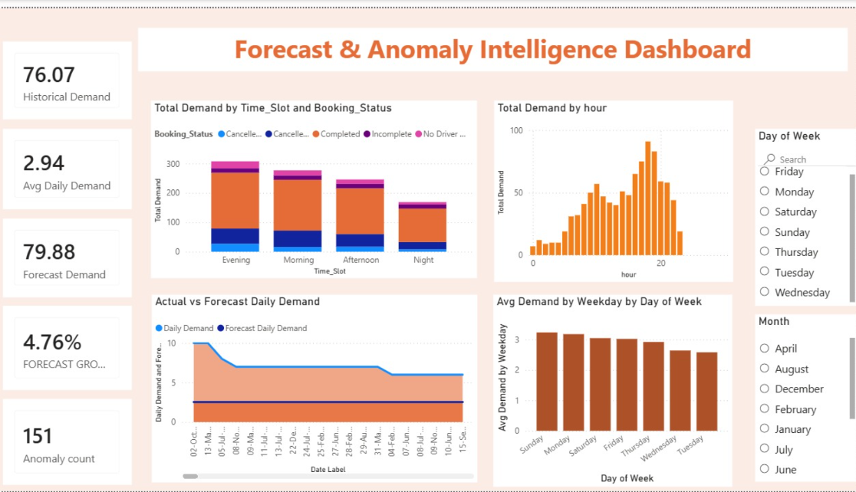

KEY ANALYTICAL OUTPUTS:
The platform was designed to generate insight across the following analytical dimensions. Specific numerical results depend on the underlying dataset values and are presented within the Power BI dashboards themselves

- Mobility demand across time periods and locations
- Influence of weather conditions on travel behavior
- Operational performance of vehicles and drivers
- Customer behavior and ride preferences
- Revenue trends across time and geography
- Seasonal variation in mobility demand
- Mode substitution patterns between transport options
- Mobility accessibility and equality across locations
CHALLENGES:
As with most real-world data analytics projects, the team encountered several practical challenges during execution. These challenges, and the general approach used to address them, are summarized below.
Challenge | Approach Taken
Missing and inconsistent values | Identified and treated during the data cleaning stage using Power Query.
Duplicate records | Detected and removed to maintain data accuracy.
Different data formats | Standardized during preprocessing for consistency across datasets.
Data-type inconsistencies | Corrected through explicit data-type conversion in Power Query.
Integrating multiple datasets | Addressed through careful key mapping and relationship design.
Handling date and time fields | Managed using dedicated date tables and time-based transformations.
Designing appropriate relationships | Resolved through iterative testing of the data model.
Choosing Star vs. Snowflake Schema | Evaluated based on query performance and reporting needs.
Creating meaningful DAX measures | Refined through iterative testing against business questions.
Large numbers of categorical values | Managed using grouping and aggregation techniques.
Selecting appropriate visualizations | Guided by the nature of each analytical question.
Representing geographical mobility data | Addressed using Power BI maps and heat maps.
Unavailable custom visuals | Substituted with suitable native Power BI visuals.
Maintaining readable dashboards | Achieved through consistent layout and design standards.

PROS AND CONS:

Pros
- End-to-end data analytics workflow, from raw data to final insights
- Interactive and user-friendly Power BI dashboards
- Multiple datasets integrated into a single analytical platform
- Structured data modeling using Star and Snowflake schemas
- Dynamic KPIs and DAX-based measures
- Use of multiple visualization techniques for different insights
- Strong mobility and geographical analysis capability
- Supports data-driven decision making for smart-city planning

Cons
- Dataset availability and quality limitations
- Missing values present in some attributes
- Limited real-time data; analysis is largely historical
- Limited geographical coverage in the available datasets
- Some advanced analysis is constrained by available dataset attributes
- Overall results depend on the quality and completeness of source datasets

LEARNINGS:
Working on this project provided the team with practical, hands-on exposure to the complete business intelligence lifecycle. Key learning outcomes include:
- Data cleaning and preprocessing techniques
- The end-to-end ETL workflow
- Power Query and the M language
- Integrating data from multiple sources
- Power BI visualization techniques
- Data modeling concepts, including Star and Snowflake schemas
- Designing relationships and date tables
- DAX, measures, and calculated columns
- KPI creation and dashboard design
- Geographical analysis using maps and heat maps
- Generating business and analytical insights
- Supporting data-driven decision making

SKILLS GAINED:

Technical Skills
- Microsoft Power BI
- Power Query
- M Language
- DAX
- Data Cleaning
- Data Transformation
- Data Modeling
- Star Schema
- Snowflake Schema
- Data Visualization
- Dashboard Development
- Data Analysis

Analytical Skills
- Pattern identification
- Trend analysis
- Comparative analysis
- Demand analysis
- Revenue analysis
- Operational analysis
- Mobility analysis
- Seasonal analysis
- Geographical analysis
- Insight generation

Professional Skills:
- Team collaboration
- Problem solving
- Presentation
- Project planning
- Data storytelling
- Analytical communication

TEAM TESTIMONIALS:

- Before this project, Power BI was just a name I had heard about. Working through the phases from Power Query to DAX helped me actually understand how a raw dataset turns into a dashboard someone can make decisions from.

- The most valuable part for me was data cleaning. Real datasets are messy, and figuring out how to handle missing values and inconsistent formats taught me more than any tutorial could.

- Working with three different datasets at once was challenging at first. Learning how to connect them through proper relationships and a Star Schema made everything click into place.

- I spent most of my time on the DAX measures. It took a few attempts to get the calculations right, but seeing the KPIs update correctly on the dashboard made it worth it.

- This project gave me a much better sense of how teams actually work together on a data project dividing tasks, reviewing each other's dashboards, and putting the final story together.

CONCLUSION:
The Infosys Urban Pulse project successfully demonstrates an end-to-end Smart City Mobility Intelligence solution built using Microsoft Power BI. The project transformed raw transportation, weather, and ride-hailing datasets into structured, analysis-ready data, and converted them into interactive dashboards and analytical insights.
The final solution provides a consolidated understanding of the following aspects of urban mobility:
- Mobility demand
- Ride-hailing performance
- Revenue
- Customer behavior
- Vehicle performance
- Weather patterns
- Seasonal trends
- Model substitution
- Mobility accessibility
- Mobility equality
Overall, the project demonstrates how data analytics and visualization can support a better understanding of urban mobility and assist data-driven smart-city decision making.
ACKNOWLEDGEMENTS:
We would like to express our sincere gratitude to our Faculty/Mentor for their guidance, valuable feedback, and continuous support throughout the course of this project.
We are thankful to our Institution/Department for providing the academic platform, resources, and environment necessary to carry out this work.
We would also like to acknowledge our project team members for their collaboration, effort, and contribution at every stage of the project.
We extend our appreciation to the providers of the transportation, weather, and ride-hailing datasets and open-data sources used in this project.
Finally, we acknowledge Microsoft Power BI and the related tools that made the development of this analytics platform possible.

